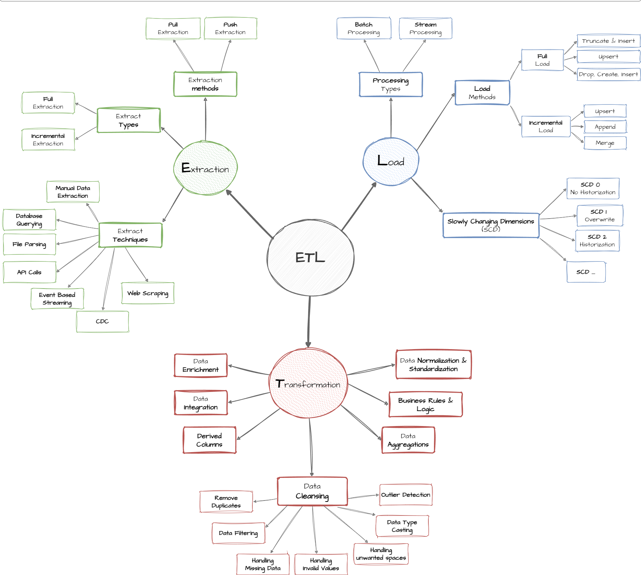

ETL PROCCES
ETL stands for Extract, Transform, Load. It is a data integration process used to collect data from different sources, convert it into a useful format, and load it into a data warehouse or other system for analysis and reporting.

1.Extraction :
Extraction is the first step in the ETL process. It means collecting raw data from different source systems.

Purpose:
To gather data from multiple sources — structured or unstructured — and bring it into a staging area for processing.

Common Data Sources:
- Databases (e.g., MySQL, PostgreSQL, SQL Server)
- Excel/CSV files
- Web APIs (e.g., weather data, stock prices)
- Cloud storage (e.g., AWS S3, Google Drive)
- Logs and IoT sensors

